

Department of Computer Science

MY University, Islamabad.

**Implementation Phase (LAB)**

**Project No: 01**

**Course Title: Database System**

**Student Name: Taha Saddiqui**

**Registration No: baib232005**

**Batch: Fall2023**

**Program: Ai**

**Semester: 6th**

**Lab Instructor: Mr. Hamza Javed**

**Submission Date: 19/03/23**

**Question 1:**Install MySQL Workbench and connect it with local server. After successfully configuration.

* Create new instance that shows your name.

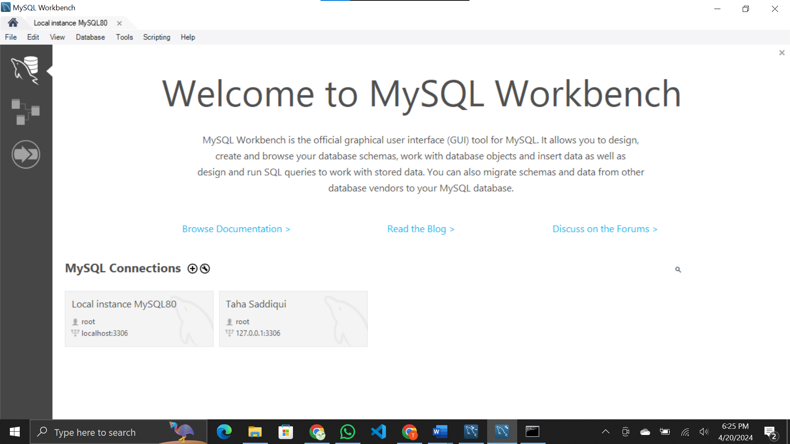

* Delete existing instances.

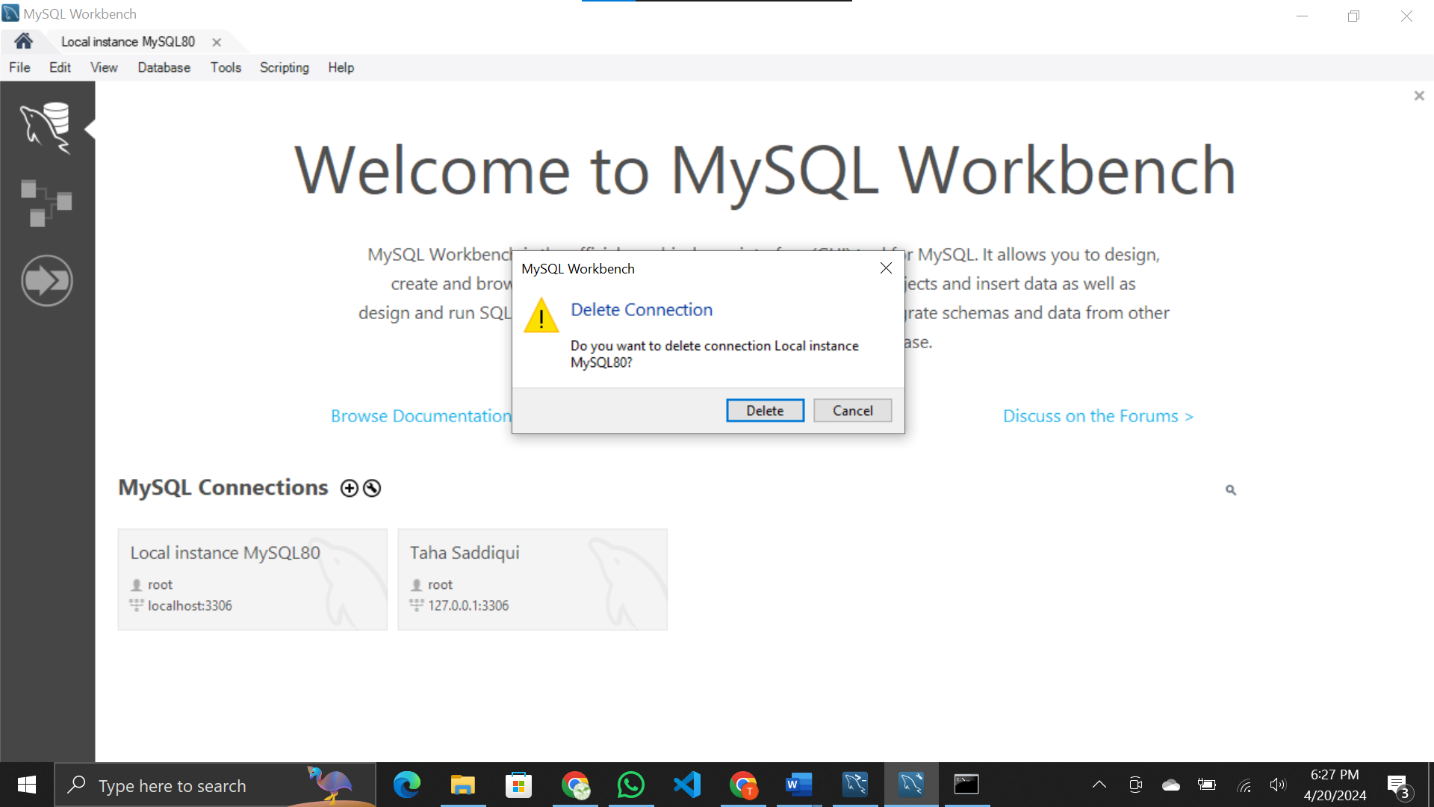

* Login to the newly created instance.

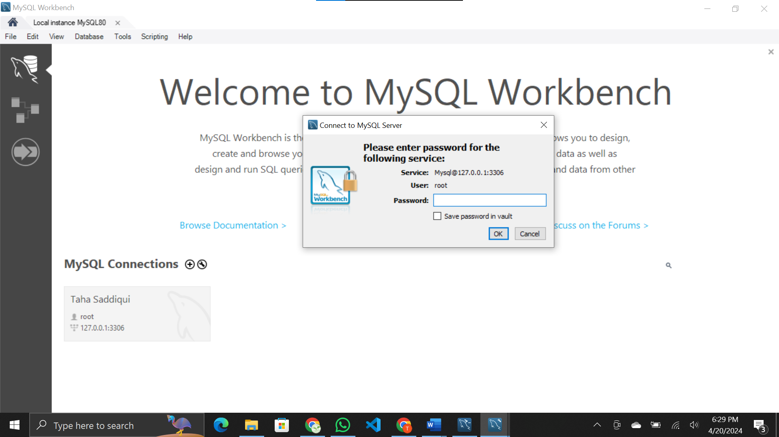

* Delete existing Schema.

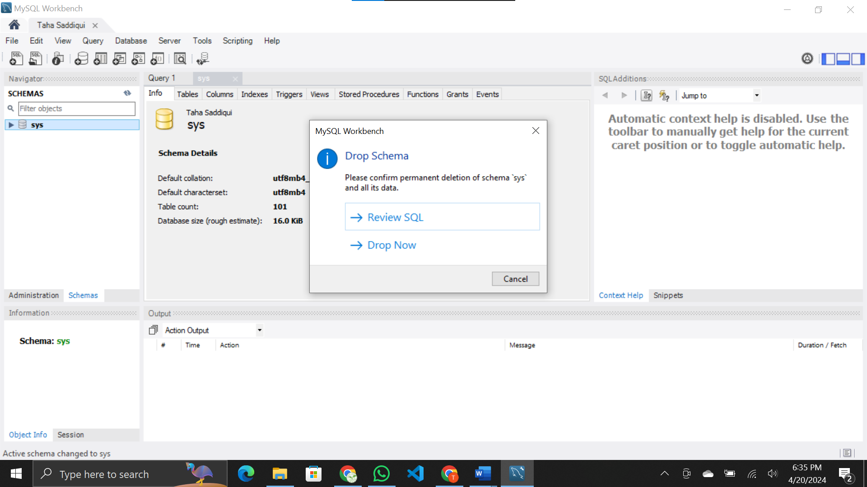

* Create a new schema that shows your name

